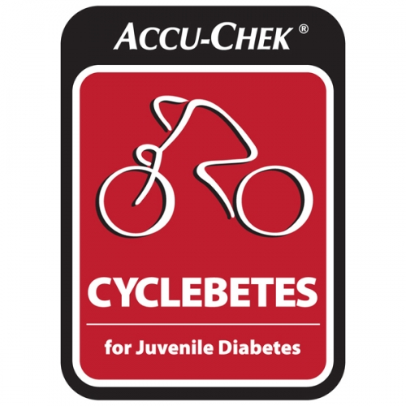Date: April 23rd, 2015
Vincent J. Maloney
Fourth Annual CYCLEBETES
STUDENT INFORMED CONSENT

Time: 8:00am - 6:30pm
Vincent J. Maloney Junior High School Gym

Accidents can be the result of the nature of the activity or can occur with or without fault on either the part of the student, the school board or staff members. By allowing your son/daughter to participate in this activity, you are accepting the risk of accident occurring, and agree that this activity is suitable for your child.

I give (name of student) _________________________________________________ permission to participate in the Vincent J. Maloney fourth annual CYCLEBETES on April 23rd, 2015 from 8:00 am to 6:30 pm.

- Students may not be riding the entire ten hours but may be providing support for their team. Students are to remain in the gym at all times unless permission is granted from one of the volunteers or teacher supervisors.
- Students will be responsible for any schoolwork missed during the bike-a-thon.
- I understand that this is a fundraising event and that my child will make every effort to raise money for Juvenile Diabetes (suggested amount is $125) in order to participate in the event.
- I understand that my child may be exposed to certain risks while participating in this activity. Accidents and injuries may occur.

Signature of Parent/Guardian: ___________________________________________

Date: _______________________________________

